

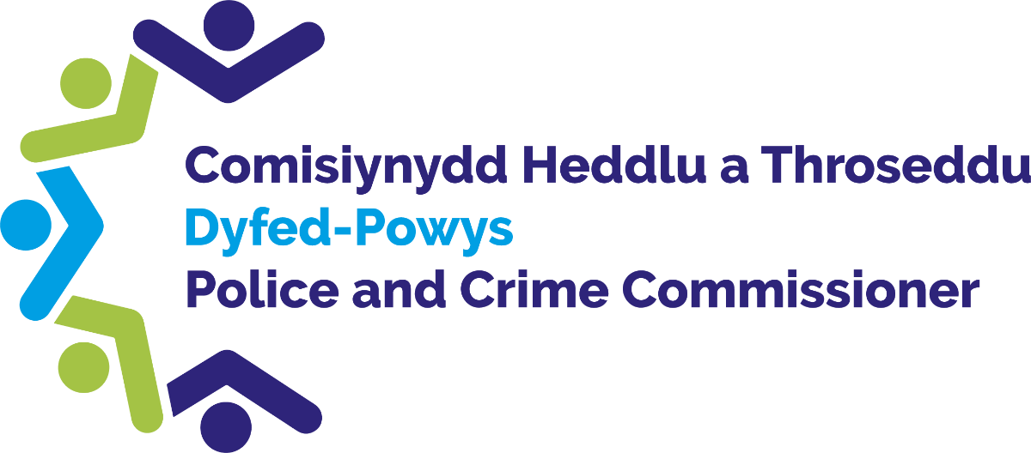

**Funding Application Form**

# Introduction

Police & Crime Commissioners across the UK have the discretion of awarding funding to various groups by exercising of the power conferred by section 143 of the Anti-social Behaviour, Crime and Policing Act 2014.

Dyfed Powys Police & Crime Commissioner has the authority to exercise this power to support his Police and Crime Plan and ensure the key priorities are met.

# Dyfed Powys Police & Crime Commissioner has funding available to communities, partners and charities through various grants and/or donations.

# Using this form

# Please use this form if you would like to apply for funding from the Police & Crime Commissioner.

# Accessibility

# If it is difficult for you to use this form or this service, for example, if English is not your first language or you have a disability, then please contact us using the details provided below:

# Telephone: 01267 226440

# Email: opcc@dyfed-powys.police.uk

# If you require any adjustments to support you to complete this application form, please let us know. For example, if you have a visual impairment, you may require written responses in larger text.

# What happens to the information in the application form?

# The information you provide on this form will be entered into our systems.

# If you require further information about how your data will be handled, please call us on 01267 226440.

# For information about how we handle your personal information, please read our privacy notice at:

# [Access to information we hold (dyfedpowys-pcc.org.uk)](https://www.dyfedpowys-pcc.org.uk/en/contact-us/access-to-information-we-hold/)

# Where to send this form:

# Please submit your completed form to the Office of the Police and Crime Commissioner (OPCC), as below:

# Email: opcc@dyfed-powys.police.uk

# Address: Dyfed Powys Police and Crime Commissioner, PO Box 99, Llangunnor,

# Carmarthen, Carmarthenshire, SA31 2PF

# Section 1 – Applicant Information

|  |  |
| --- | --- |
| Organisation/ Applicant details | |
| Organisation Name |  |
| Organisation Address |  |
| Applicant Name(s) |  |
| Applicant email addresses |  |
| Applicant(s) contact number(s) |  |

|  |  |
| --- | --- |
| 1.2. Organisational Structure | |
| Organisation Type*(i.e. Community Group, Charity, Educational Establishment, Public Body, Social Enterprise etc)* |  |
| Company or Charity Number(if applicable) |  |
| Name & email of Organisation Lead(i.e. Chief Executive, Chief Officer or Chief Finance Officer) |  |
| Organisation Address |  |

# Section 2 – Project Detail

|  |  |
| --- | --- |
| Summary Information | |
| Project Title |  |
| Project Short description(max. 100 words) |  |
| Proposed start date for project activities |  |
| Proposed end date for project activities |  |
| Project Location(s)(Specify towns/ communities) |  |
| Brief description of expected project outcomes and evaluation plans(max. 300 words) |  |

|  |
| --- |
| 2.2. Project description |
| Please provide a detailed description of the proposed activity(max. 500 words) |
|  |
| Funding requests must demonstrate that they meet the priorities detailed in the Commissioner’s Police & Crime Plan. Details of the priorities can be found here:[The Police and Crime Plan 2025 - 2029](https://www.dyfedpowys-pcc.org.uk/en/the-commissioner/police-and-crime-plan/)Please indicate which of the Police & Crime Plan priorities will be met*(please tick all that apply) |
| Supporting Victims and Preventing Victimisation Supporting Safe Communities by Preventing Harm Supporting a More Effective Justice System*\* Funding is unlikely to be provided if the project does not meet at least one of these priorities.* |
| Please describe how your project will meet the Police & Crime Plan priorities(max. 500 words) |
|  |
| Please detail why there is a need for your project, either locally or regionally and how it meets this need?(max 500 words) |
|  |
| Please describe what difference your project will make to your community?Please describe any feedback/ consultations held with partners, residents and/or community groups.(max 500 words) |
|  |
| Please provide details of any previous funding received from the Police & Crime Commissioner.(max 500 words) |
|  |
| Who will deliver the project (please any include delivery partners supporting this project)?(max. 500 words) |
|  |
| Please detail any engagement with other Statutory Bodies in relation to this project (this can include receiving advice, guidance and/or financial support).If your activity is better aligned to other Statutory Bodies’ responsibilities, we may not be able to offer funding but may be able to support you in other ways.(max 500 words) |
|  |
| Please list the intended beneficiaries of this project.(max. 100 words) |
|  |

|  |
| --- |
| 2.3 Welsh Language Provision |
| If relevant for this application, can you please confirm that project activity can embrace the Welsh Language? Not Relevant Yes Maybe * No \**\* Further discussions may be required to understand the barriers* |
| If Maybe or No, please provide reasons why your project cannot embrace the Welsh Language?(max. 300 words) |
|  |

|  |  |  |  |  |
| --- | --- | --- | --- | --- |
| 2.4 Funding Required | | | | |
| Total amount of funding required | | £ | | |
| Total project cost | | £ | | |
| Please provide a breakdown of how the funding will be spent.If you are requesting multi-year funding, please enter the first year of funding activity here.Additional years’ breakdown can be included at Q3.1 below.(max. 300 words) | | | | |
| Funding periodtimeframe |  | | Funding requested (£) | Match funding value (£) |
| Activity breakdown description | | |
|  | | |  |  |
|  | | |  |  |
|  | | |  |  |
|  | | |  |  |
|  | | |  |  |
|  | | |  |  |
|  | | |  |  |
|  | | |  |  |
|  | | |  |  |
|  | | |  |  |
|  | | |  |  |
| TOTAL | | |  |  |
|  | | | | |
| We encourage applicants to self-finance and/or seek funding from a variety of sources. Does the project include any match funding from yourselves or other sources?If yes, please explain who else is providing funding and how this will be used.(max. 500 words) | | | | |
|  | | | | |
| If the amount of funding does not exceed £4,999.99 please go to Section 5 | | | | |

|  |
| --- |
| 2.5 Partnership/ Collaborative Working |
| Please detail any collaborative partners and/or other organisations involved in this project (this can include other Statutory Bodies).Please describe their role in the project.(max 500 words) |
|  |
| Please include any statistical data that has been collected and/or analysed to support and develop this project.If you do not currently have an evidence base to demonstrate the need for your project, please describe how this funding will develop a data baseline.(max 500 words) |
|  |
| Have you received any and/or are in the process of applying for other funding for this project? Please provide details and values.(max 500 words) |
|  |

|  |
| --- |
| Section 3 – Delivery |

|  |  |  |  |
| --- | --- | --- | --- |
| 3.1 Funding: multi- year | | | |
| Please provide a breakdown of funding for each year of your project (from year 2 onwards)Please provide supplementary detail if required | | | |
| Funding periodtimeframe |  | Funding requested (£) | Match funding value (£) |
| Activity breakdown description | |
|  | |  |  |
|  | |  |  |
|  | |  |  |
|  | |  |  |
|  | |  |  |
|  | |  |  |
|  | |  |  |
|  | |  |  |
|  | |  |  |
|  | |  |  |
| Funding periodtimeframe |  | Funding requested (£) | Match funding value (£) |
| Activity breakdown description | |
|  | |  |  |
|  | |  |  |
|  | |  |  |
|  | |  |  |
|  | |  |  |
|  | |  |  |
|  | |  |  |
|  | |  |  |
|  | |  |  |
|  | |  |  |

|  |
| --- |
| 3.2 Project Delivery and Governance |
| Please provide a delivery plan setting out key milestones and dates for the delivery of the project.Additional files will be accepted if there isn’t sufficient space below.(max. 500 words) |
|  |
| Please detail what governance and financial management arrangements are in place to manage the funding.(max. 500 words) |
|  |
| Please provide details of any identified risks to delivery (including likelihood and impact). Please describe the process that will be used to monitor and manage project risks.Please include a risk register if available.(max. 500 words) |
|  |
| Please describe your organisation’s experience in funding project delivery.(max. 500 words) |
|  |

|  |
| --- |
| 3.3 Social Value |
| Please describe how your project will benefit the local community by using social value initiatives. |
|  |
| Please describe how your project will support the UK’s net zero ambitions and/or wider environmental impacts |
|  |
| Please describe how your project will provide economic sustainability to Dyfed Powys communities. |
|  |

|  |
| --- |
| Section 4 – Monitoring and Evaluation |

|  |
| --- |
| 4.1 Monitoring |
| Please describe how you will monitor milestones of project delivery and manage any unforeseen circumstances.(max. 300 words) |
|  |
| Please detail how you will measure performance of the project against its aims and objectives. Please include qualitative and/or quantitative metrics as appropriate.If appropriate, this should also include how you will capture any new and/or unexpected benefits identified during project implementation and delivery.(max. 300 words) |
|  |
| Please describe how you comply with the provisions and obligations outlined in the General Data Protection Regulations (GDPR) *[UK GDPR guidance and resources | ICO](https://ico.org.uk/for-organisations/uk-gdpr-guidance-and-resources/)(max 300 words)*\* Funding is unlikely to be provided if the Organisation does not have appropriate policies in place* |
|  |

|  |
| --- |
| 4.2 Evaluation |
| Please describe how you will evaluate the effectiveness of the project including key performance indicators and/or measures.If available, this should include your evaluation plan agreed at the outset of your project.(max. 300 words) |
|  |
| Do you have an Exit Strategy on how the project will be maintained following the end of the funding period?This should include sustainability plans and future funding models as appropriate. |
|  |

|  |
| --- |
| 4.3 Equality, Diversity and Inclusion |
| a) Does your organisation have a formal Equality, Diversity, and Inclusion (EDI) policy or strategy?☐   Yes☐    No☐   Not relevant\**\* Further discussions may be required to understand the barriers*If yes, please provide a brief overview or attach a copy of the policy/strategy.(max. 300 words) |
|  |
| If No, or Not relevant, please provide reasons why?(max. 300 words) |
|  |
| How does your organisation ensure that its work is inclusive and accessible to diverse communities, including minority underrepresented groups?(max. 300 words) |
|  |
| Is the proposed funding activity specifically targeted at, or done in collaboration with, any minority, marginalised or underrepresented community groups?☐   Yes☐    NoPlease describe the communities or groups involved and the nature of the collaboration.(max 300 words) |
|  |
| What measures do you have in place to monitor and evaluate the inclusivity of your work, particularly with regard to reaching diverse communities and addressing any barriers to participation.(max 300 words) |
|  |
| Does your organisation offer any training or development on EDI for your staff, volunteers or stakeholders?☐   Yes☐    NoIf yes, please provide a brief description of the training or development provided.(max 300 words) |
|  |
| How does your organisation engage with or seek input from diverse communities to inform and shape its services or activities?(max 300 words) |
|  |
| If your proposed activity involves working with vulnerable or minority groups, what steps will you take to ensure their safety, dignity, and well-being throughout the project?(max 300 words) |
|  |

|  |
| --- |
| Section 6 - Declaration |

|  |  |  |  |
| --- | --- | --- | --- |
| 5.1 Senior Officer approval | | | |
| Please confirm that you have received authorisation to submit this application from your Organisational Lead(i.e. Chief Executive, Chief Officer, or Chief Finance Officer) Yes No | | | |
| Senior Leader Name: | |  | |
| Senior Leader Signature: | |  | |
| Senior Leader email: | |  | |
| Approval date: | |  | |
| Please confirm that you have received authorisation to submit this application from all Partner organisations listed at 2.2f Not applicable Yes No | | | |
| **5.2. Applicant Signature** | | | |
| Applicant Signature: | | |  |
| Applicant Name: | | |  |
| Applicant Position: | | |  |
| 1. **Date:** | | |  |
| **5.2. Applicant Signature** | | |
| Applicant Signature: | |  |
| Applicant Name: | |  |
| Applicant Position: | |  |
| 1. **Date:** | |  |
| **5.3 Due Diligence Questionnaire** | | |
| If your funding request exceeds £4,999.99, please complete the questionnaire and return with your application. | | |