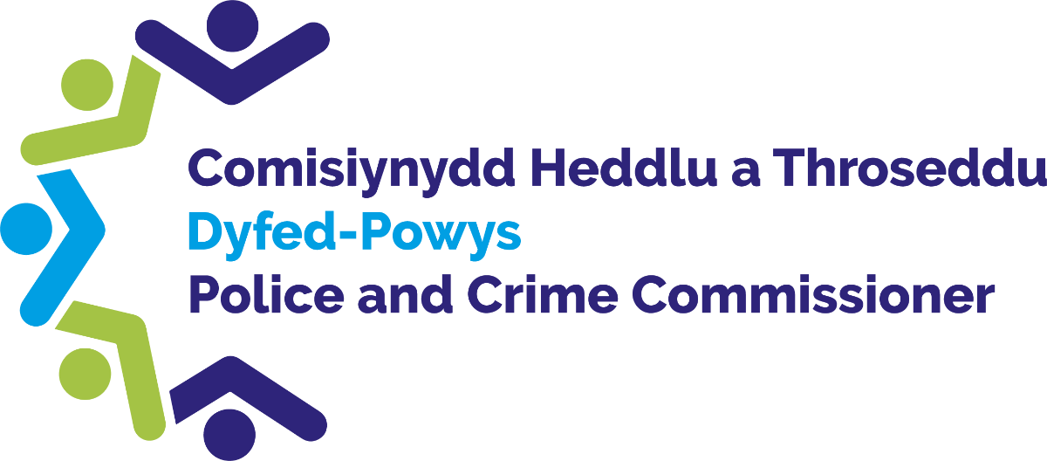

Funding Application Form

Introduction
Police & Crime Commissioners across the UK have the discretion of awarding funding to various groups by exercising of the power conferred by section 143 of the Anti-social Behaviour, Crime and Policing Act 2014.
Dyfed Powys Police & Crime Commissioner has the authority to exercise this power to support his Police and Crime Plan and ensure the key priorities are met.

Dyfed Powys Police & Crime Commissioner has funding available to communities, partners and charities through various grants and/or donations.

Using this form

Please use this form if you would like to apply for funding from the Police & Crime Commissioner.

Accessibility

If it is difficult for you to use this form or this service, for example, if English is not your first language or you have a disability, then please contact us using the details provided below:

Telephone: 01267 226440

Email: opcc@dyfed-powys.pnn.police.uk

If you require any adjustments to support you to complete this application form, please let us know. For example, if you have a visual impairment, you may require written responses in larger text.

What happens to the information in the application form?

The information you provide on this form will be entered into our systems.

If you require further information about how your data will be handled, please call us on 01267 226440.

For information about how we handle your personal information, please read our privacy notice at:

Access to information we hold (dyfedpowys-pcc.org.uk)

Where to send this form:

Please submit your completed form to the Office of the Police and Crime Commissioner (OPCC), as below:

Email: opcc@dyfed-powys.pnn.police.uk

Address: Dyfed Powys Police and Crime Commissioner, PO Box 99, Llangunnor,

Carmarthen, Carmarthenshire, SA31 2PF

Section 1 – Applicant Information

Organisation/ Applicant details

Organisation Name

Organisation Address

Applicant Name(s)

Applicant email addresses

Applicant(s) contact number(s)

1.2. Organisational Structure

Organisation Type

(i.e. Community Group, Charity, Educational Establishment, Public Body, Social Enterprise etc)

Company or Charity Number

(if applicable)

Name & email of Organisation Lead

(i.e. Chief Executive, Chief Officer or Chief Finance Officer)

Section 2 – Project Detail

Summary Information

Project Title

Project Short description

(max. 100 words)

Proposed start date for project activities

Proposed end date for project activities

Project Location(s)

(Specify towns/ communities)

Brief description of expected project outcomes and evaluation plans

(max. 300 words)

2.2. Project description

Please provide a detailed description of the proposed activity

(max. 500 words)

Funding requests must demonstrate that they meet the priorities detailed in the Commissioner’s Police & Crime Plan. Details of the priorities can be found here:

The Police and Crime Plan (dyfedpowys-pcc.org.uk)

Please indicate which of the Police & Crime Plan priorities will be met*

(please tick all that apply)

☐ Victims are Supported

☐ Harm is prevented

☐ Our justice system is more effective

* Funding is unlikely to be provided if the project does not meet at least one of these priorities

Please describe how your project will meet the Police & Crime Plan priorities

(max. 500 words)

Please detail why there is a need for your project, either locally or regionally and how it meets this need?

Please describe what difference your project will make to your community?

Please describe any feedback/ consultations held with partners and/or community.

(max 500 words)

Please provide details of any previous funding received from the Police & Crime Commissioner

(max 500 words)

Who will deliver the project (please any include delivery partners supporting this project)?

(max. 500 words)

Please list the intended beneficiaries of this project.

(max. 100 words)

2.3 Welsh Language Provision

If relevant for this application, can you please confirm that project activity can embrace the Welsh Language?

☐ Not Relevant

☐ Yes

☐ Maybe *

☐ No *

* Further discussions may be required to understand the barriers

If Maybe or No, please provide reasons why your project cannot embrace the Welsh Language?

(max. 300 words)

2.4 Funding Required
Total amount of funding required |  | £

Please provide a breakdown of how the funding will be spent.

If you are requesting multi-year funding, please enter the first year of funding activity here.

Additional years’ breakdown can be included at Q3.1 below.

(max. 300 words)

Funding period |  |  | Funding requested (£) | Match funding value (£)

Activity breakdown

Does the project include any match funding from yourselves or other sources? If yes, please explain how this will be used.

(max. 300 words)

If the amount of funding does not exceed £4,999.99 please go to Section 5

2.5 Partnership/ Collaborative Working

Please detail any collaborative partners and/or other organisations involved in this project. Please describe their role in the project.

(max 500 words)

Please include any statistical evidence that have taken place to support and develop this project.

(max 500 words)

Have you received any and/or are in the process of applying for other funding for this project? Please provide details and values.

(max 500 words)

Section 3 – Delivery

3.1 Funding: multi- year

Please provide a breakdown of funding for each year of your project (from year 2 onwards)

Please provide supplementary detail if required

Funding period |  | Funding requested (£) | Match funding value (£)

Activity breakdown
Funding period |  | Funding requested (£) | Match funding value (£)

Activity breakdown

3.2 Project Delivery and Governance

Please provide a delivery plan setting out key milestones and dates for the delivery of the project.

(max. 500 words)

Please detail what governance and financial management arrangements are in place to manage the funding.

(max. 500 words)

Please provide details of any identified risks to delivery (including likelihood and impact). Please describe the process that will be used to monitor and manage project risks.

(max. 500 words)

Please describe your organisation’s experience in funding project delivery.

(max. 500 words)

3.3 Social Value

Please describe how your project will benefit the local community by using social value initiatives.

Please describe how your project will support the UK’s net zero ambitions and/or wider environmental impacts

Please describe the advantages your project will have on the economic, social and environmental wellbeing of your communities.

Section 4 – Monitoring and Evaluation

4.1 Monitoring

Please describe how you will monitor milestones of project delivery and manage any unforeseen circumstances.

(max. 300 words)

Please detail how you will measure performance of the project against its aims and objectives. Please include qualitative and/or quantitative metrics as appropriate.

If appropriate, this should also include how you will capture any new and/or unexpected benefits identified during project implementation and delivery.

(max. 300 words)

Please describe how you comply with the provisions and obligations outlined in the General Data Protection Regulations (GDPR) *

UK GDPR guidance and resources | ICO

(max 300 words)

* Funding is unlikely to be provided if the Organisation does not have appropriate policies in place

4.2 Evaluation

Please describe how you will evaluate the effectiveness of the project including key performance indicators and/or measures.

If available, this should include your evaluation plan agreed at the outset of your project.

(max. 300 words)

Do you have an Exit Strategy on how the project will be maintained following the end of the funding period?

Section 5 - Declaration

5.1 Senior Officer approval

Please confirm that you have received authorisation to submit this application from your Organisational Lead

(i.e. Chief Executive, Chief Officer, or Chief Finance Officer)

Lead Organisation Signature:

Please confirm that you have received authorisation to submit this application from all Partner organisations listed at 2.2f

☐ Not applicable

☐ Yes

☐ No

5.2. Applicant Signature

Applicant Signature:

Applicant Name:

Applicant Position:

- Date:

