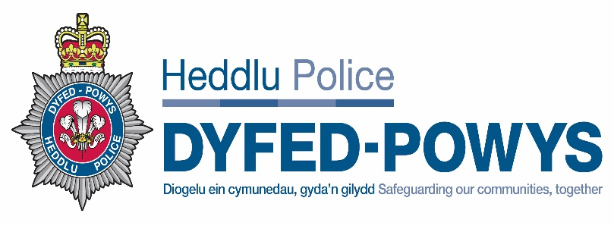
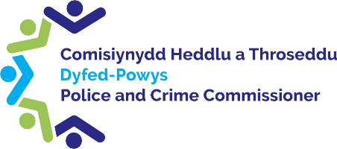
DYFED-POWYS
POLICE AND CRIME COMMISSIONER
AND CHIEF CONSTABLE

Joint Audit Committee
Annual Report
2023/24
Chair’s Foreword

I present to you as Chair, my second annual report on the work of the Dyfed-Powys Police and Crime Commissioner and Chief Constable’s Joint Audit Committee (JAC). The Joint Audit Committee’s purpose is to provide independent assurance and advice on governance processes. For example, it considers the arrangements for risk management and financial management and on occasions challenges the processes in place to assure itself that they are fit for purpose.

Following a recruitment drive at the end of last financial year and the beginning of 2023/24 we have been lucky to appoint two new members to the Committee. David Macgregor brings with him a wealth of experience from the public sector and Julie James a wide range of skills and experience from the private sector. I thank them both for taking the time to apply to become members. I also pay thanks to Farhan Shakoor and Brian Jones for their continued support as Members of the Committee and I value all of your contributions to the meetings.

From a financial perspective 2023/24 was a challenging year as the Committee was asked to sign off the Statements of Accounts for both 2021/22 and 2022/23. The 2021/22 process was a particularly protracted one and the Committee sought to understand the reasons behind the delay and met with Audit Wales prior to the sign off the 2022/23 accounts to ensure that lessons had been learned in relation to the preparation of the accounts and it was satisfying to know that they had.

The work undertaken by the JAC continues to be extensive and a decision was made at the end of this financial year that to allow the Committee to undertake its work with due diligence there is a need to extend the number of meetings per year to 5. This will allow the Committee to have sufficient time in meetings to undertake our role efficiently and effectively.

This year has been a challenging one again in relation to financial risks to the organisations with funding being cut in key areas such as PCSO’s and the Schools Programme, but it is reassuring to see that the high-level financial plans are able to absorb these issues to a certain extent due to the significant amount of work that goes in to preparing the Medium-Term Financial Plan. I would like to take the opportunity to thank the officers of the Police and Crime Commissioner and the Chief Constable along with the internal auditors TIAA and the staff of Audit Wales who have supported the Committee.

Kate Curran,
Joint Audit Committee Chair.

The Joint Audit Committee

The purpose of the Joint Audit Committee (JAC) is to provide independent assurance to the Police and Crime Commissioner (PCC) and Chief Constable (CC) on the adequacy of the governance and risk management frameworks, the internal control environment, and financial reporting, thereby helping to ensure efficient and effective arrangements are in place.
The JAC has been established in accordance with the Home Office Financial Management Code of Practice, issued under the Police Reform and Social Responsibility Act 2011 and in line with the Chartered Institute of Public Finance and Accountancy (CIPFA) guidance.
Members of the JAC have an understanding of the financial, risk and control, and corporate governance issues facing the PCC and CC. They also have the ability to challenge, question, probe, and seek clarification from the PCC and CC when required.
The Membership of the JAC during 2023/24 was as follows:
Member | Number of meetings scheduled to attend | Number of meetings attended | % of meetings attended
Kate Curran (Chair) | 4 | 3 | 75%
Farhan Shakoor | 4 | 4 | 100%
Brian Jones | 4 | 3 | 75%
David MacGregor | 4 | 3 | 75%
Julie James | 1 | 1 | 100%

Each member of the JAC have been vetted and completed a declaration of interest form.

The JAC meetings are also attended by the PCC and CC, the PCC’s Chief Executive and Chief Finance Officer and the CC’s Director of Finance. Other officers attend to provide information about audits, programmes of work, or any other matters as required.
During two recruitment drives (one commenced towards the end of the previous financial year) two new members of the Committee were appointed. David Macgregor attended his first meeting in July 2023 and Julie James attended her first meeting in March 2024. The Committee is now at full complement, ensuring resilience to enable appropriate review and challenge at each meeting.
Members of the Committee also attend internal governance meetings of the Force to provide an added layer of assurance. Those meetings are:
- Audit Governance Group
- Corporate Governance Group
- People, Culture and Ethics Board
- Strategic Estates Group
- Commissioning Advisory Board
- Learning the Lessons Board
- ICT Strategic Group
- Information Assurance Board
Meetings

The meetings held during this period have all been held virtually via Microsoft Teams. In addition to the formal JAC meetings, Members have attended additional seminars as highlighted below.

Members were invited to the Police and Crime Commissioner’s Finance Seminar in November 2023 which provided stakeholders with an overview of the operational and financial challenges facing the service. This served to contextualise the programme of governance work being undertaken by the JAC and was deemed to be beneficial to all involved.
Members also received an input at the Finance Seminar from Link Group, the Treasury Management Advisors on the current economic position, market conditions and explained the key elements which needed consideration for the relevant financial strategies. An update was also given from the Force Review Team in relation to how the Force are seeking to reshape and reform to meet both current and future financial challenges, whilst also delivering a high-quality service to the communities of Dyfed Powys.

A Statement of Accounts seminar was held in February 2024 between Members, the Chief Finance Officer, the Director of Finance and finance leads within the Force to consider the vast level of detail within the draft Statement of Accounts. This exercise was considered very useful in terms of reviewing the accounts and related documents with very valuable discussions taking place. The Committee also had an input on the Annual Governance Statement and an update from Audit Wales.

Programme of work for 2023/2024

The Joint Audit Committee held 4 formal meetings in 2023/24. During these meetings, the committee received reports, recommendations, and observations from internal auditors TIAA, Audit Wales and HMICFRS updates. The Committee also received presentations from officers of the OPCC and Force on key business areas for them to formulate an independent opinion and provide assurance to the PCC and CC in respect of the financial and governance controls within the Corporation Soles.
The programme of work included the following:

Risk Management: JAC paid particular attention to the risk registers of the OPCC and the Force. Through discussions at the early meetings in 2023/24 the format of reporting was changed following feedback from Members. The JAC challenged areas on the Risk Register to ensure that risks contained within the register were appropriately detailed and clear.

Information Management: In previous years the Committee has considered a report on information management on an annual basis however, due to significant issues in relation to backlogs in dealing with Freedom of Information requests and Subject Access Requests a report was presented to each meeting during the year. The Force had self-referred to the Information Commissioners Office due to the issues. JAC is closely monitoring of progress thereby adding an additional level of review and challenge.
Governance: The JAC received updates on actions from both the Corporate Governance Group and the Audit Governance Group. This allowed the Members to follow various issues through the governance structure before final consideration by themselves. At the meeting held in January 2024 the Committee considered an update report from the Audit Governance Group and raised concerns in relation to the number of recommendations that remained open for 6 or more months. The Committee requested information on why there are such delays and they were advised in the March meeting that a new tracker was being utilised to ensure that recommendations were addressed in a more timely manner. The Committee also requested that consideration should be given to those outstanding recommendations and where appropriate should be included on the risk register. This work was undertaken and the appropriate recommendations included on the register.
Financial Reporting – The Committee considered and signed off two sets of Statements of Accounts during the year. In July 2023 the Committee signed of the accounts for financial year 2021/2022 and in March 2024 the accounts for 2022/23 were signed off. In addition, the Committee were kept up to date on issues relating to the preparation of the Annual Statement of Accounts for 2023/24. Members took a keen interest into the feedback in relation to the preparation of the 2021/2022 accounts and asked Officers to demonstrate that lessons had been learned to improve future accounts preparation. In addition, the Committee considered the Medium-Term Financial Plan, Treasury Management Strategy, Reserves Policy and the Capital Strategy.

Internal Audit: The JAC received reports on the work undertaken by the internal auditors TIAA. 22 specific internal audit reports were considered by the Committee during 2023/24. 13 were internal assurance reviews in relation to Dyfed Powys and included topics of HR Management, ICT Disaster Recovery, Business Continuity and Estates. A further 9 reviews were reviews of collaborative work being undertaken between all Welsh Forces and included topics of Fleet Management, Payroll, Debtors and Creditors. As part of their role Members were able to challenge the information contained within the reports and seek assurance where issues had been identified that the remedial work would be undertaken to drive improvements. On occasions where there were specific serious issues identified the Committee requested an update report be presented to a future meeting to demonstrate any progress that has been made. Committee Members also took an interest in the scope of reviews and requested that more focus is given to the initial scope of future reviews to ensure that outcomes add value and be of organisational benefit. During the year 10 reviews received substantial assurance, 11 reviews received reasonable assurance and 1 review had limited assurance. At the end of the year there were 3 reviews outstanding and these will be considered during the next meeting cycle.

Training Needs Analysis – during the year the Committee undertook an exercise to establish whether there were any training or development requirements for Members. The information will be considered during the 2024/2025 year and arrangements will be made for appropriate training to be delivered. Consideration will also be given to any national training opportunities that may be provided.
Terms of Reference – following a review of the terms of reference in February 20023 the Committee considered and approved the revised terms of reference at the meeting held in July 2023. The terms of reference are based on CIPFA guidance and will be reviewed on an annual basis.

Priorities for the Committee in 2024/25 include:/

- Continue to oversee the preparation of the Statement of Accounts for 2023/24 in consultation with Audit Wales and seek assurance that lessons have been learned from previous years.
- Consider and advise on financial management arrangements which are considered on an ongoing basis to further develop the medium-term financial plan
- To focus on key areas of business, in support of the PCC and CC’s priorities, including:
  - Revised Corporate Governance Framework
  - Risk Management through an internal audit review of the Assurance framework
  - Internal Audit, ensuring value for money and maximum benefit to the Force
  - Information Management through continued monitoring of the implementation of recommendations form the ICO
  - A revised Counter Fraud policy
  - Monitoring the implementation of the recommendations from previous internal audit reviews

!

Contact Details

Office of the Police and Crime Commissioner PO Box 99, Llangunnor, Carmarthen, SA31 2PF 01267 226440
opcc@dyfed-powys.police.uk www.dyfedpowys-pcc.org.uk
@dpopcc

