

Police and Crime Commissioner for Dyfed-Powys

Scrutiny Panel
Dip Sampling Exercise

Drug Offences

Panel Members’ Findings & Feedback

June 2024
Contents

1.0 Overview 2
2.0 Background, purpose, and methodology 2
3.0 Approval by Panel Chair 3
4.0 Actions taken following previous panel meeting 3
5.0 Areas for improvement 4
6.0 Consideration of Adult Cases for Drug offences 4
7.0 Consideration of Youth cases for Drug Offences 7
8.0 Panel’s assessments to date 11
9.0 Ethnicity and Gender 14
10.0 Future Panel focus 14
11.0 Actions 14

Overview
On the 17th of June 2024, members from the Out of Court Disposal (OoCD) scrutiny panel attended a meeting to review a selection of nine youth and nine adult cases involving either the possession of drug(s) or the intent to supply drugs, which had been dealt with by way of an Out of Court Disposal (OoCD).
This meeting was conducted virtually via Microsoft Teams.

Background, purpose, and methodology
The purpose of the OoCD panel is to independently assess, scrutinise and quality control the use of OoCD by Dyfed-Powys Police. The panel can make recommendations, feedback on individual cases to officers, communicate findings, promote best practice and identify potential policy development or training needs for consideration by the force or other agencies involved. The panel cannot change the original outcome of the case.
The panel membership consists of partners from within the Criminal Justice System which include, but not limited to, members from Dyfed-Powys Police, the OPCC, Probation Service, Crown Prosecution Service, Youth Justice Team and Magistrates bench.
The panel members collectively agree an area of focus for each meeting. They receive relevant case files two weeks prior to each meeting which have been randomly selected by the Panel Chair. The Panel then meets to discuss each case and where possible reach a conclusion as to the appropriateness of the disposal. In deciding this, the Panel considers the following criteria:
• The views and feedback from the victim and the offender.
• Compliance with force policy.
• Rationale for the decision and outcome.
• Potential community impact.
• Circumstances and seriousness of the offence.
• Potential alternative options that may have been available.
The Panel discuss each case and categorise them as one of the following:
• Appropriate use consistent with policy.
• Appropriate use with Panel Members’ reservations.
• Inappropriate use or inconsistent with policy.
• Panel fails to reach a conclusion.

Approval by Panel Chair

I _ __ Carys Morgans (print name) can confirm that I have read the report, and that it fully represents the views expressed by the Panel during our dip sampling exercise dated 17th of June 2024.

Signed: 
Date: 11.12.2024 __

Actions taken following previous panel meeting
As a result of the Out of Court Disposal Scrutiny Panel’s work, the following actions have been completed since the last meeting:
- An ongoing action from the meeting held on the 24th April 2023 remains ongoing in relation to marking Youth Case 6 to have future cases to be brought to court. Ongoing efforts have been made for the current police database system, known as Niche, to utilise a flagging system, which will notify investigating officers that an OoCD should not be provided for this individual. Unfortunately, so far, this has not been possible to be incorporated in the Niche system and with the person responsible unavailable for this meeting, it was felt best to keep this action ongoing to understand the exact difficulties. The Youth Offending Team (YOT) are aware of the individual and will advise accordingly if the youth is brought to police attention.
- An action, following from the previous meeting held on the 7th February 2024, for feedback to the officer’s involvement with Adult Case 4, was highlighted and completed. The feedback included the panel’s observations that the use of force used to enter the dwelling and the subsequent damage caused had impacted the victim, who noted a desire to pursue with a conviction, meaning that OoCD was inappropriate.
- Officers involved with Adult case 5 from the last meeting (7th February 2024) have been provided with feedback regarding the panel’s findings. The Panel found that a community resolution was deemed inappropriate due to the number of previous convictions the adult had in relation to a number of offences within a six-week time period.
- Officers involved with Adult case 6 from the last meeting (7th of February 2024) have been provided with feedback regarding the Panel’s findings that the adult had likely pre-meditated an intention to commit the offence due to the high value of goods involved. Whilst the panel found the community resolution outcome to be appropriate, they had reservations due to the impact this may have had on the victim and their ability to claim compensation if the matter was not being brought to court.
- Officers involved with Adult case 8 from the last meeting (7th of February 2024) have been provided with feedback regarding the Panel’s findings that the OoCD was inappropriate due to the adult’s shoplifting background and had previously stolen from the same store. The panel also noted the high value of goods stolen and highlighted that the Adult had breached their community order.

5.0 Areas for improvement
The following area for improvement was identified as a result of the Panel’s work this quarter:
- Dyfed Powys Police officers to be reminded of the OoCD policy and when it is appropriate to issue an OoCD.
- Dyfed Powys Police officers to be reminded that Youth Referral Disposals (YRD) are not appropriate to be used in circumstances whereby by a youth has been involved for drug offences.

6.0 Consideration of Adult Cases for Drug offences
As of the 16th of October 2023, a pre-arrest diversion policy change for adults only in ‘simple possession’ offences was implemented as part of a pilot project to expand the diversion of drug users to treatment by way of an Adult Community Resolution (ACR). This being a public health approach to the threat of drug dependency in our communities and its link to criminality and offending.
In essence, from that point onwards, police officers can now issue ACRs for any ‘simple drug possession’ (any type of drug) unlimited times (no restriction on number of ACRs an individual can receive) for individuals, even if hardened users (previous convictions and intelligence does not determine eligibility).
The nine adult cases selected for drug offences included possession of illegal drug substance, Possession with the Intent to Supply (PWITS) and unlawful importation of illicit drugs. All nine adult cases were issued with a community resolution.

Members’ assessment | Number of cases
Appropriate | 6
Appropriate use with reservations | 2
Inappropriate | 1

Panel Members’ observations are detailed below.
Case 1
The Panel noted that there did not appear to be a test for drug driving by the officers involved. The Panel noted that blood tests had not been looked at, that there were areas missing from the case in relation to Drug Driving offences and that the perpetrator appeared to have been allowed to leave using their vehicle. Had there not been the issue of potential drug driving to explore, based on current policy, the use of an ACR would have been appropriate; however, if an investigation of drug driving had been pursued, the drug in question seized from the car may have formed part of the evidential case to substantiate drug driving. The Panel also raised concerns in relation to the driver admitting to smoking cannabis throughout the day and that the officer involved reported smelling a strong smell of cannabis emanating from within the vehicle.
Panel’s Assessment: Inappropriate
Action 1:
Officer involved in Adult case 1 needs to be informed of the Panel’s findings regarding the handling of a Drug and Drive offence.

Case 2
The Panel acknowledged the sensitivity surrounding this case, particularly as the adult was found in possession of drugs with a young minor involved. The Panel also noted that this was a good example of collaboration between the officer and external partners in providing a considered and balanced approach with also excellent consideration for the child involved. The Panel recognised that this adult needed support and was unlikely to receive this should it have gone to court. The Panel concurred that a rationale for the decision to issue an ACR is desirable; however, not essential as the officer has acted in accordance with current force drug policy and is empowered to determine outcome for a ‘simple possession’ case. Officers have been encouraged to maximise diversion to treatment opportunities and focus upon catching and convicting drug dealers.
Panel’s Assessment: Appropriate use with reservations
Action 2
Feedback to be provided to the officer and partner agencies involved with Adult case 2 to highlight the positive work and the comprehensive report conducted.

Case 3
The Panel acknowledged that very small amount of cannabis was found on this adult’s possession with also a minimal amount of white powder. In addition, the officer reported finding scales within the vehicle, which if examined, could potentially lead to a higher drug offence. The Panel recognised that officers have acted in accordance with current Drug policy and operational expectation where officers are encouraged to be proportionate in their investigative strategies ensuring that there is a likely successful criminal justice outcome worthy of the committal of resources, before causing unnecessary forensic (to include digital devices) examinations that will create demand and prevent us servicing higher priorities in an effective, timely manner.
Panel’s Assessment: Appropriate
Action 3
When acquiring the cases from the Force, if there are additional charges, explore options to obtain a summary to assist panel’s final decision.

Case 4
The panel noted that the adult had had provided a “no comment” interview and from a court’s perspective, this would be interpreted as a not guilty plea for prosecution. However, other members of the Panel discussed that the acceptance of an ACR for drug possession is an admission of possession of the drug in question and willingness to enter the diversionary mechanism as an alternative to the criminal justice route. The individual signed the ACR to that effect. Whilst there is police intelligence indicating that this individual has concerns for dealing; the new Drug policy has no regard to previous convictions or intelligence if determined to be in ‘simple possession’ of drugs. The aim of the policy is a public health approach, the alternative outcome to a criminal justice route of limited deterrence, is offering drug users treatment opportunities however many times it takes.
Panel’s Assessment: Appropriate
Case 5
The panel noted the vulnerability associated with this adult, particularly their mental health and that they appeared distressed. The adult admitted to the injection of the drug substance. There was previous for drug offences but over 10 years ago and the individual was taken straight to a crisis ward by officers, which was deemed to be appropriate.
Panel’s Assessment: Appropriate
Case 6
The panel discussed that the individual had no previous background for any offences prior to this incident and had admitted to the offence.
Panel’s Assessment: Appropriate
Case 7
The panel advised that as the individual had no previous convictions and that the OoCD complied with the policy; therefore, the panel deemed it appropriate.
Panel’s Assessment: Appropriate
Case 8
The panel recognised that the adult was found with a small amount of cannabis and had also admitted to the use of the drug. The issue of the ACR to the adult for a ‘simple drug possession’ is appropriate and in accordance with current Drug Policy. A rationale for the decision to issue an ACR is desirable, however not essential as the officer has acted in accordance with current force drug policy and is empowered to determine outcome for a ‘simple possession’ case. The current drug policy allows individuals to receive an ACR multiple times and regardless of previous convictions / intelligence. Officers have been encouraged to maximise diversion to treatment opportunities and focus upon catching and convicting drug dealers.
Panel’s Assessment: Appropriate use with reservations
Case 9
The panel specified that as this adult had no previous convictions and had admitted the offence, the OOCD was appropriate.
Panel’s Assessment: Appropriate

7.0 Consideration of Youth cases for Drug Offences
Panel members reviewed nine cases. Of those nine cases, four cases were issued with a Youth Restorative Disposal (YRD), two received a Youth Conditional Caution (YCC), and three with a Community Resolution (CR).
Members’ assessments were as follows:
Members’ assessment | Number of cases
Appropriate use and consistent with policy | 1
Appropriate use with reservations | 1
Inappropriate | 5
Fail to reach conclusion | 2

Case 1
The panel raised concerns with this Youth case specifying that there appears to be an ongoing issue with the Force with regards to issuing YRDs to youths for drug offences. It does not appear that this officer had consulted with the local Youth Offending Team (YOT) for advice or for guidance, as YRDs cannot be provided to youths for drug offences. It has been noted as an ongoing issue with the Force. The Force provided their input on this matter advising that work is currently underway to prevent the selection of drugs for YRDs via the computer software Niche. A representative from YOT has emphasised that a new strategy is also under development to ensure that officers link in with them for guidance associated with YRDs. The Chair has also suggested that this be added to the agenda for the next Policing Board meeting for escalation consideration.
Panel’s Assessment: Inappropriate
Action 6:
Ongoing issue concerning YRDs offered to youths for drug offences despite this being raised previously. This was found in Youth 1, Youth 3, Youth 4 and Youth 5.

Case 2
The panel noted that this was a comprehensive report with a good rationale as to why a YCC was considered to be appropriate; however, the panel had reservations surrounding the number of previous offences and a previous CR provided within a period of two years. The question of whether a YCC would prevent the Youth from continuing their use of drugs. The Youth also presented with a “no comment” interview which does not indicate admission of the offence; although, the Youth had admitted to the substance and its use at the point of arrest; therefore, it was undecided whether this Youth had fully admitted to the offence. OoCD requires some level of remorse and by providing a “no comment” interview, perhaps this does not reflect full acceptance of their responsibility.
Panel’s Assessment: Appropriate use with reservations
Action 7:
Feedback to officer involved in Youth 2 regarding Panel’s findings concerning requirement for full admission.

Case 3
Similar to Youth case 1, a YRD was used for drugs offences with a minor. The panel considered that this case should have been brought to the Youth Justice Team’s (YJT) attention. The quantity associated with this offence was described as “Tennis Ball size” which is considered to be a large quantity. The officer’s involved did not notify YOT for guidance and did not appear to liaise with the partner force associated with the home address of the Youth.
Panel’s Assessment: Inappropriate
Action 6:
Ongoing issue concerning YRDs offered to youths for drugs offences despite this being raised previously. This was found in Youth 1, Youth 3, Youth 4 and Youth 5.
Action 8:
Individual feedback that the officer needs to liaise with YOT and the appropriate force of the home address for Youth case 3.

Case 4
This is another instance whereby a YRD was used for drug offences associated with a youth. The Youth involved with this incident had previously been given a YCC for Battery and Drugs offences. It does not appear that the appropriate checks and contact with YOT had been made by the officer in case (OIC).
Panel’s Assessment: Inappropriate
Action 6:
Ongoing issue concerning YRDs offered to youths for drugs offences despite this being raised previously. This was found in Youth 1, Youth 3, Youth 4 and Youth 5.
Action 9:
Specific feedback to the officer involved in Youth case 4 in relation to liaising with YOT and conducting appropriate checks prior to issuing a YRD.

Case 5
This is another instance where a YRD was issued incorrectly to a youth in relation to drug offences. In addition, it appears that the drug driving offence was handled separately to the possession of drugs. This youth has a background of two previous YRDs and a Youth caution. It does not appear that YOT were consulted on this case.
Panel’s Assessment: Inappropriate
Action 6:
Ongoing issue concerning YRDs offered to youths for drugs offences despite this being raised previously. This was found in Youth 1, Youth 3, Youth 4 and Youth 5.

Case 6
A small amount of drugs were found on the Youth’s possession. YOT were consulted with regards to this case and a bureau assessment was also provided by the YJT.
Panel’s Assessment: Appropriate
Case 7
The external members of the panel had difficulty ascertaining the outcome and paperwork associated with this case. Members of the panel who are within the Force, advised that a community resolution had been completed and passed to the relevant YJT and a bureau report is available on the police software system known as Niche. However, this information was not included in the summary for the panel to review. It was for this reason, the panel could not reach a unanimous decision.
Panel’s Assessment: Fail to reach conclusion
Action 10:
Feedback to be provided to the local YJT in Ceredigion. Both Youth cases 7 & 9 the Panel were unable to reach a conclusion due to no bureau report.

Case 8
The panel specified that this referral had not consulted with YOT and a CR can not be provided by a member of the response team. The case has also received oversight by a sergeant who had closed the case under Outcome 15 (doesn’t meet evidential threshold)
Panel’s Assessment: Inappropriate
Action 11:
Sergeant and officer feedback to be given in relation to the findings made by the Panel for Youth case 8.

Case 9
The panel were unable to see the outcome of this case due to not receiving the bureau assessment. It was noted that the youth had specified an admission of what was found in the property; however, the occurrence report is not clear. There was a large sum of cash and a quantity of drugs found at the location which may suggest Possession With Intent To Supply (PWITS); however, due to a lack of rationale provided, it was unclear who the bag containing the drugs actually belonged to.
Panel’s Assessment: Fail to reach conclusion
Action 10:
Feedback to be provided to the local YJT in Ceredigion. Both Youth cases 7 & 9 the Panel were unable to reach a conclusion due to no bureau report.

8.0 Panel’s assessments to date
The chart below demonstrates the Panel’s assessment of Drug Offence cases considered at the most recent meeting:
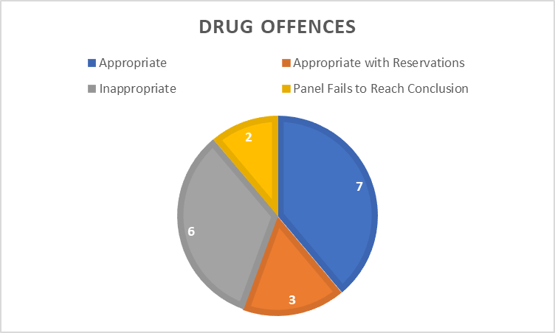
Since November 2013 the Panel has considered a range of disposals, as displayed in the graph below.
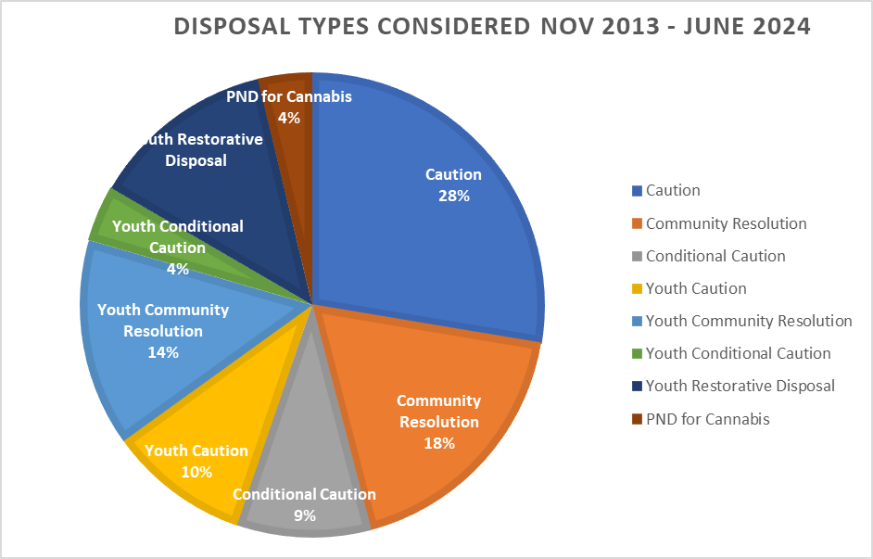
Of the 624 cases examined between November 2013 and June 2024, 58% were assessed as appropriate, 21% as inappropriate, 19% as appropriate with reservations and the panel failed to reach a conclusion in 2% of cases.
The change in conclusions reached over time can be seen in the graph below:

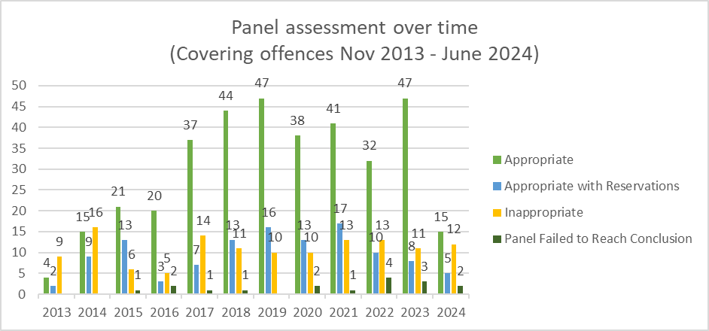
The graph below shows the breakdown by crime type as a percentage of cases considered between November 2013 and June 2024.
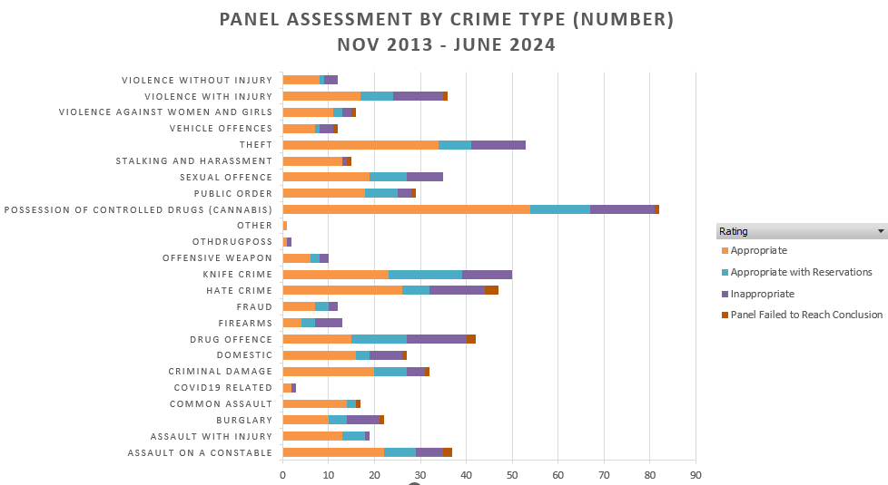

The following graph displays the actual number of cases assessed within each crime type and the resulting Panel opinions at their meetings between November 2013 and June 2024.
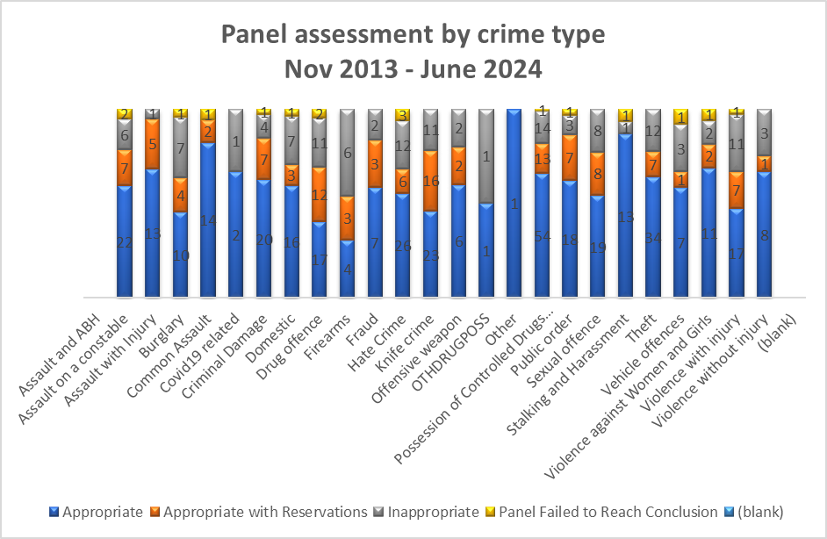

9.0 Ethnicity and Gender
The following chart shows the breakdown of cases reviewed within this meeting in terms of their gender:
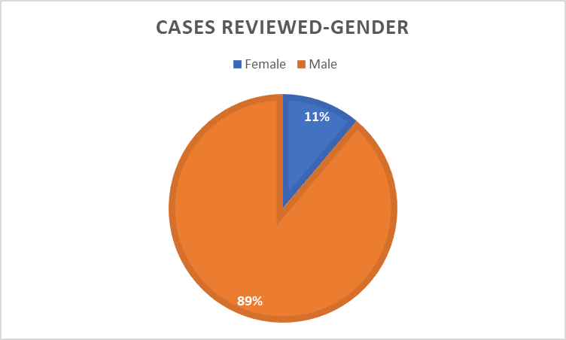

The following table shows the breakdown of cases reviewed within this meeting in terms of ethnicity.
Ethnicity Noted | Suspect’s  Self - Assessment | Officer’s Assessment
White British | 13 | 0
White – North European | 0 | 14
White | 1 | 0
Black | 1 | 0
Black African inc Black British | 0 | 1
Not stated | 3 | 0
Unknown | 0 | 3

In three of the cases reviewed, ethnicity was not recorded. There were no race or gender equality issues identified as part of the Panel’s review.

10.0 Future Panel focus
Following a discussion, it was decided by the Panel that they would like to focus on Assault and Actual Bodily Harm (ABH) charges to members of the public at the next meeting.

11.0 Actions

Meeting Date | Rec. No. | Recommendation | Person Responsible
24/04/2023 | OOCD-120 | Youth Case 6 to be marked so that any future offences are brought to court. | Judith Jenkins
17/06/2024 | OOCD-133 | Circulate amendments to the ToR. | Tom Walters
17/06/2024 | OOCD-134 | When acquiring the cases from the Force, if there are additional charges, explore options to obtain a summary to assist panel’s final decision. | Tom Walters/Cedwyn Rogers
17/06/2024 | OOCD-135 | Officer involved in Adult case 1 needs to be informed of the Panel’s findings regarding the handling of a Drug and Drive offence. | Ch Insp Matthew Price
17/06/2024 | OOCD-136 | Feedback to be provided to the officer and partner agencies involved with Adult case 2 to highlight the positive work and the comprehensive report conducted. | Ch Insp Matthew Price
17/06/2024 | OOCD-137 | Ongoing issue concerning YRDs offered to youths for drugs offences despite this being raised previously. This was found in Youth 1, Youth 3, Youth 4 and Youth 5. | Ch Insp Jenna Jones
17/06/2024 | OOCD-138 | Feedback to officer involved in Youth 2 regarding Panel’s findings concerning requirement for full admission. | Ch Insp Jenna Jones
17/06/2024 | OOCD-139 | Individual feedback that the officer needs to liaise with YOT and the appropriate force of the home address for Youth case 3. | Ch Insp Michael Llewellyn
17/06/2024 | OOCD-140 | Specific feedback to the officer involved in Youth case 4 in relation to liaising with YOT and conducting appropriate checks prior to issuing a YRD. | Ch Insp Michael Llewellyn
17/06/2024 | OOCD-141 | Sergeant and officer feedback to be given in relation to the findings made by the Panel for Youth 8. | Ch Insp Steve Thomas
17/06/2024 | OOCD-142 | Feedback to be provided to the local YJT in Ceredigion. Both Youth cases 7 & 9 the Panel were unable to reach a conclusion due to no Ceredigion Bureau report | Davinia Harries-Davies

